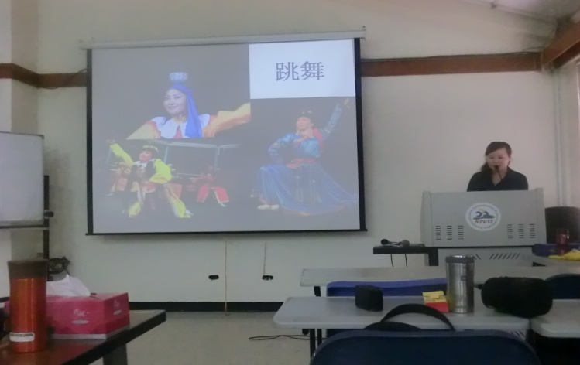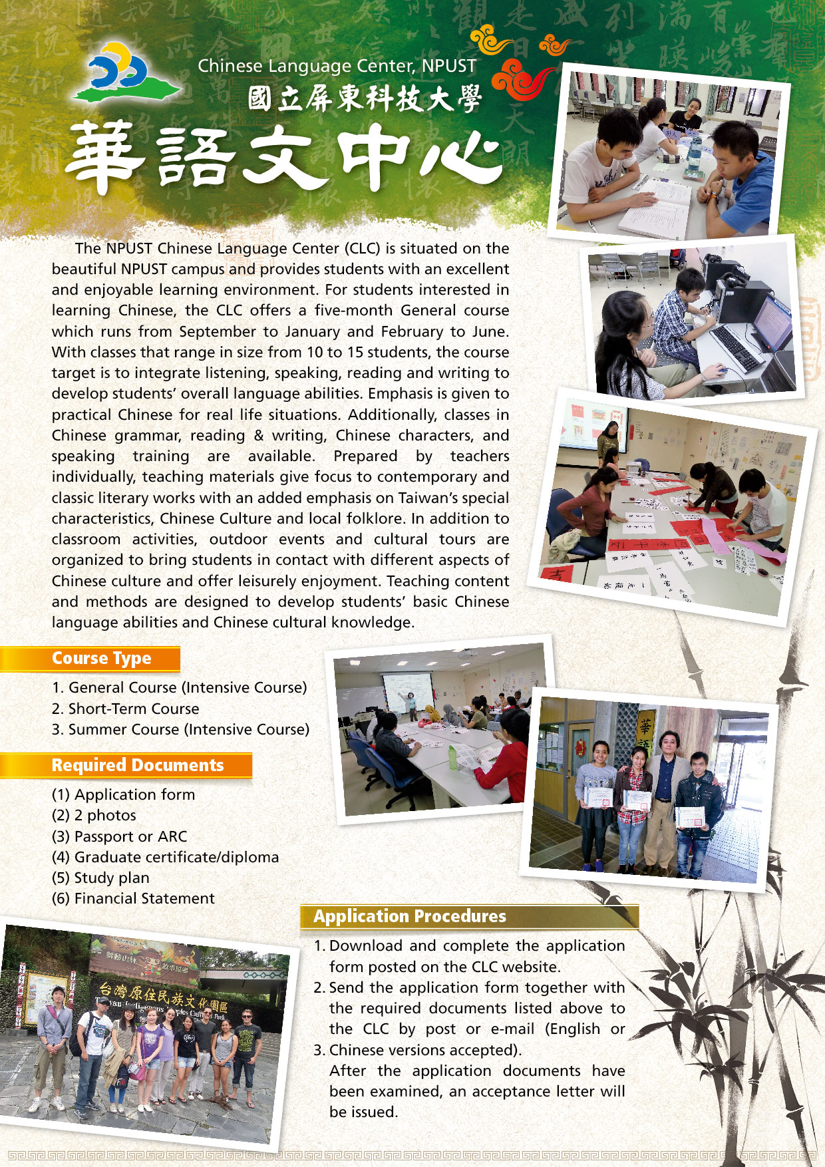

|  |  |
| --- | --- |
| Date | 14:30~16:30, December 17st, 2014 |
| Application Deadline | 5 pm., December 12th, 2014 |
| How to register | Fill out the application form and submit to CLC. |
| Registration | 14:00~14:30, December 17st, 2014 |
| Venue | IC205 |

**2014 Chinese Language Center Mandarin Courses Performance**

**103-1華語文中心成果發表會**

* **活動目的**：藉由比賽使華語文中心華語課程學生開口說華語，分享學習華語成果。

**Purpose:** To encourage foreign students from CLC Mandarin courses present their Mandarin skills and share what students have learnt from the courses.

* **活動時程Time Schedule**：

|  |  |
| --- | --- |
| 活動日期 | 2014年12月17日 14:30~16:30 |
| 報名截止日 | 2014年12月12日 17:00 |
| 報名方式 | 填寫報名表並繳交至華語文中心 |
| 報到時間 | 2014年12月17日14:00~14:30 |
| 活動地點 | IC205 |

* **參與資格 Eligibility**：

以華語文中心華語課程學生為主，也歡迎本校其他外國學生一同參與同樂。

The students take Mandarin courses from CLC. NPUST foreign students are also welcome to join as the guests.

* **組別Groups**：

1. 初階組 Beginner 2.進階組 Advanced

* **演出方式 Presentation**：
* 表演時間以5分鐘為限。Time is limited in 5 minutes.

1. 唱歌 Singing：自行選定中文歌曲一首 Choose one Mandarin song.
2. 演講Speech: 演講比賽的主題自訂，可自行準備背景影片或其他數位檔案。

Any topics and any accessory materials are welcome.

1. 演戲Drama：主題自訂，可自行準備背景影片或其他數位檔案。

Any topics and any accessory materials are welcome.

* **評審Judge**：

3位短期課程教師為評審，計分方式以合計3名裁判評分，排列名次順序。

There will be 3 judges from the Mandarin Courses teachers, arranging the place in order.

* **獎勵 Prizes：**優勝者可獲得獎狀一紙及本校書軒書局抵用券一張。

1st Prize: a certificate and NT$500 coupon. 2nd Prize: a certificate and NT$300 coupon.

3rd Prize: a certificate and NT$100 coupon. Best performance award: a certificate.

* **備註Remarks**：

本規則若有未盡事宜，主辦單位得適時修正補充之，最新資訊公佈於華語文中心網站上。

Notice will be revised or added if necessary and the latest information will be provided on the official website.

**\*Teaching Features:** The target of this course is to integrate listening, speaking, reading and writing, which emphasis on virtual living uses. Moreover, we organize out-door events and cultural tours for students to come into contact with different Chinese culture, and enjoy their leisure time.