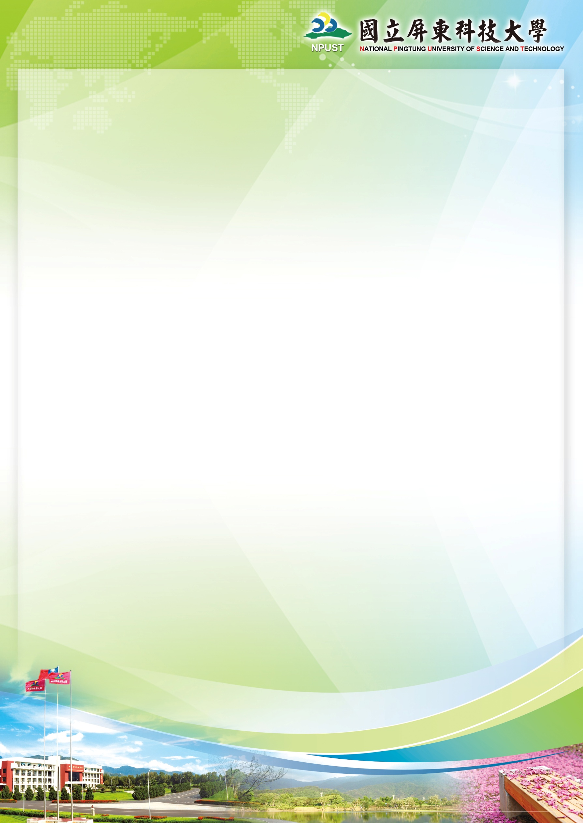**113-1 TA Training Course for International Students**

Subject: How to be a successful TA

Date: 2024.09.09 (Mon.)

Time: 15:30-17:30

Location: 2nd Conference Room

**Class Timetable:**

|  |  |  |
| --- | --- | --- |
| **Agenda** | **Time** | **Instructor** |
| **Registration** | 15：20~15：30 |  |
| **Class 1** | 15：30~16：20 | Sylvia Yang  (楊慈品教師) |
| **Break** | 16：20~16：30 |  |
| **Class 2** | 16：30~17：20 | William Hsu  (許耿誌教師) |
| **Test** | 17：20~17：30 |  |